**Aim: -** To acquire the result by varying the different parameters through simulation.

1. **Amplitude Modulation:-**

**DSB-FC**

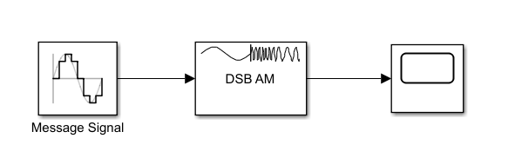**Modulator:-**

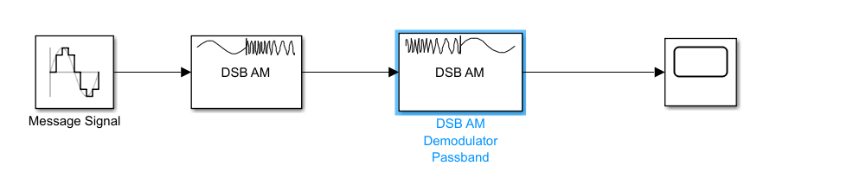**Demodulator:-**

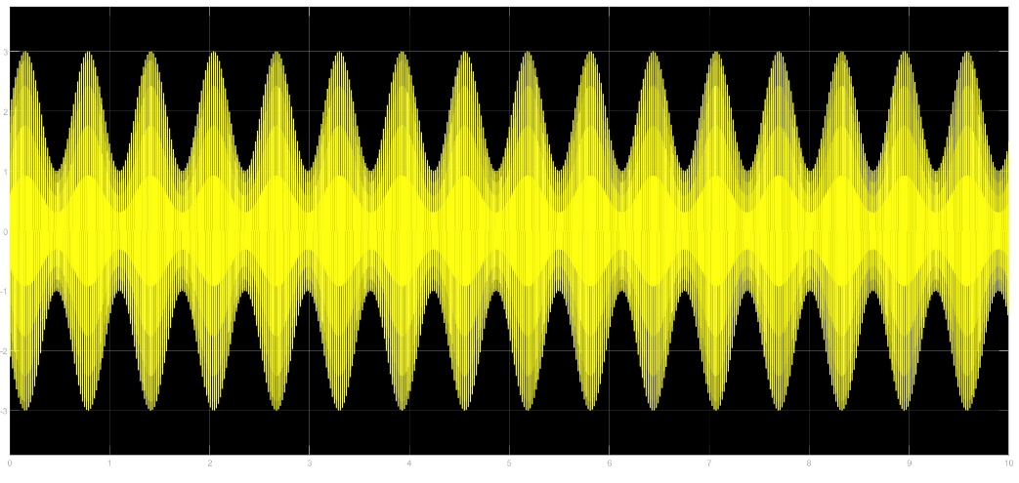**Under Modulation :-**

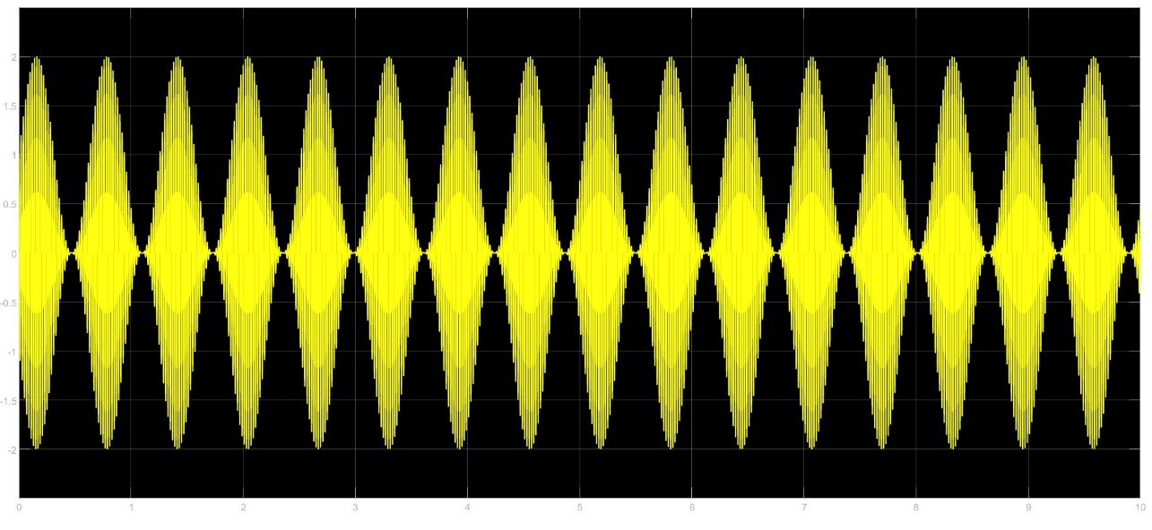**Perfect Modulation:-**

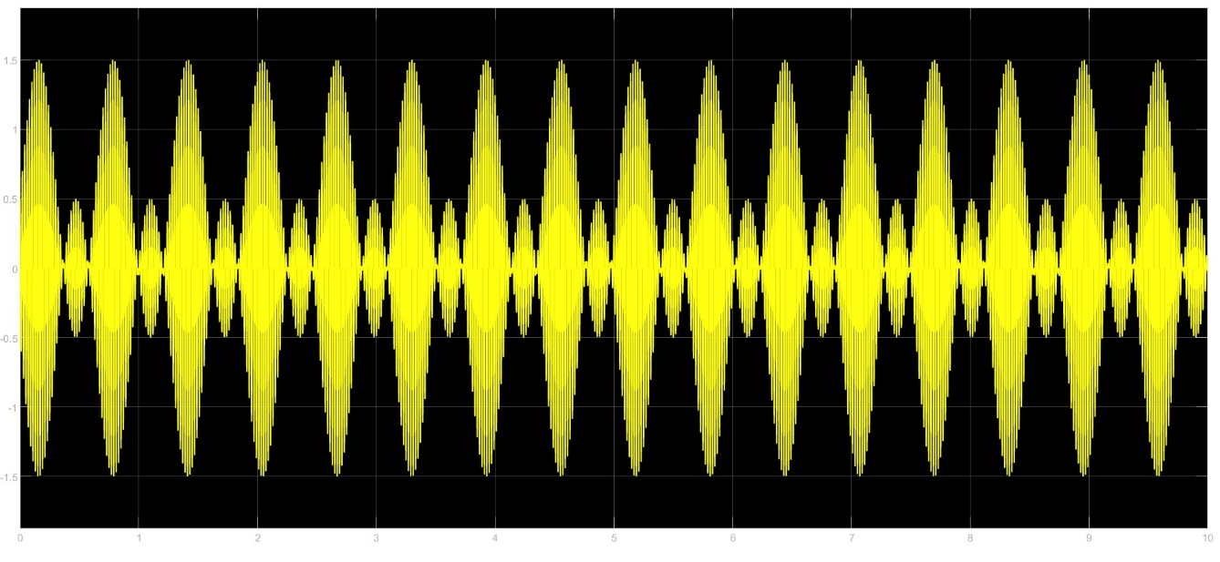**Over Modulation:-**

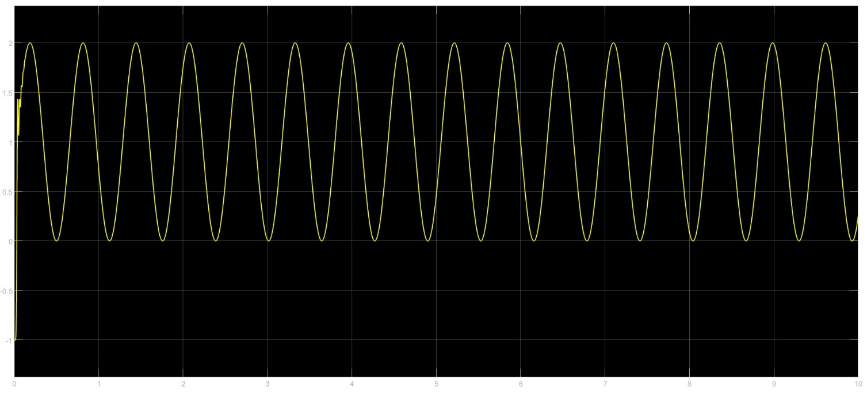**Demodulation:-**

**DSB-SC:-**

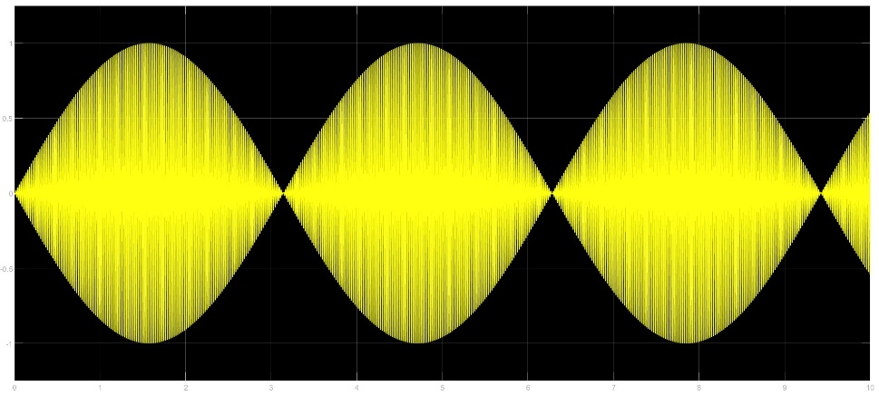**Modulator:-**

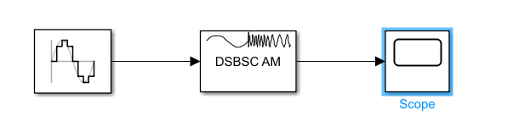

**Demodulator:-**

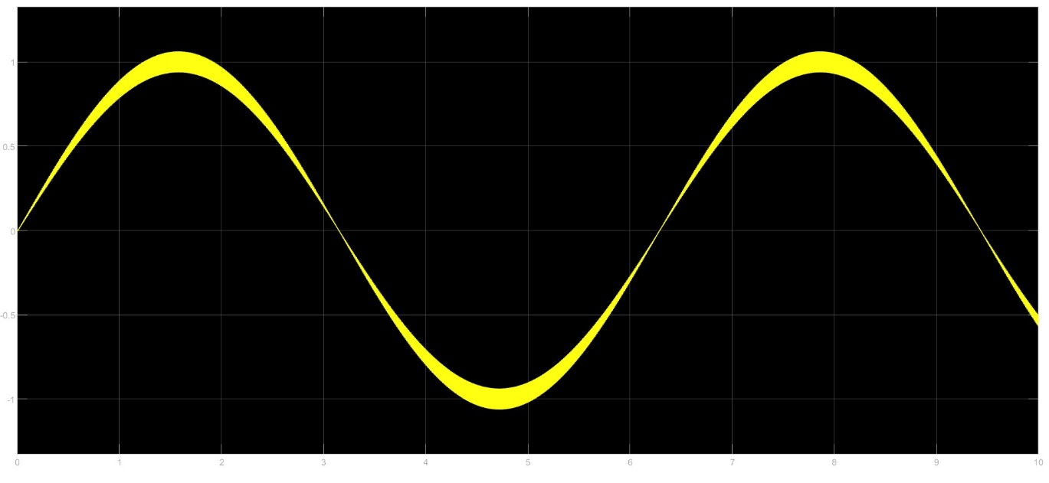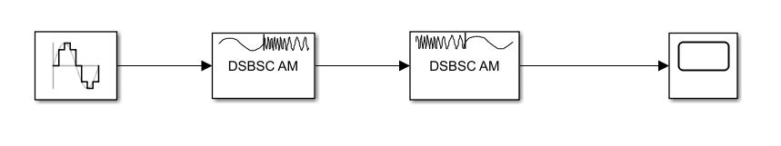

* **Parameter: Modulation index**
* **Effect: Increasing the modulation index increases the amplitude variations in the modulated signal, resulting in a higher magnitude of sidebands, more power consumption**
* **Conclusion: A higher modulation index leads to a more power consuption.**

1. **Frequency Modulation:-**

**Modulation:-**

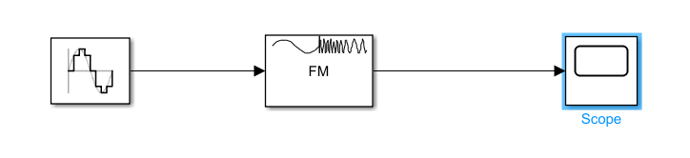

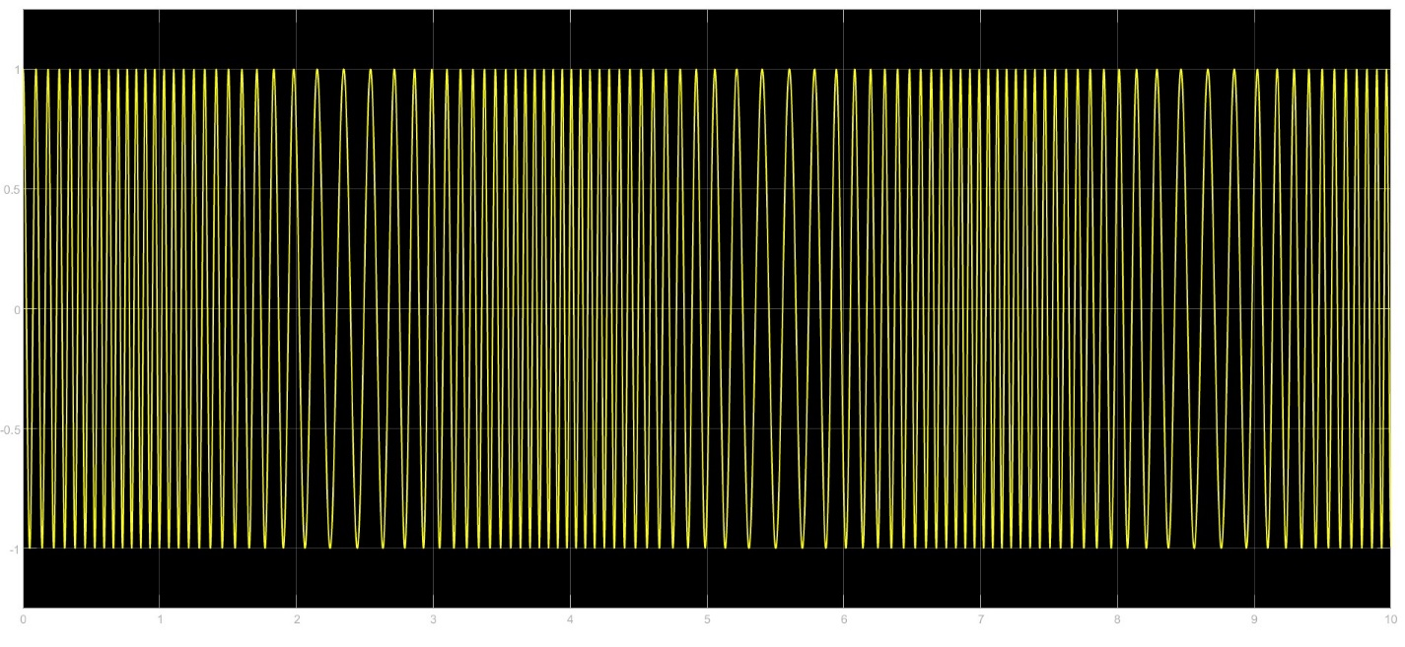

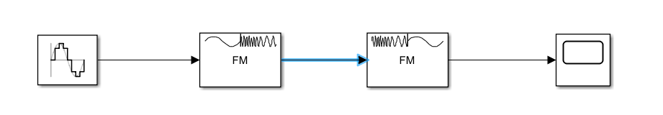**Demodulation:-**

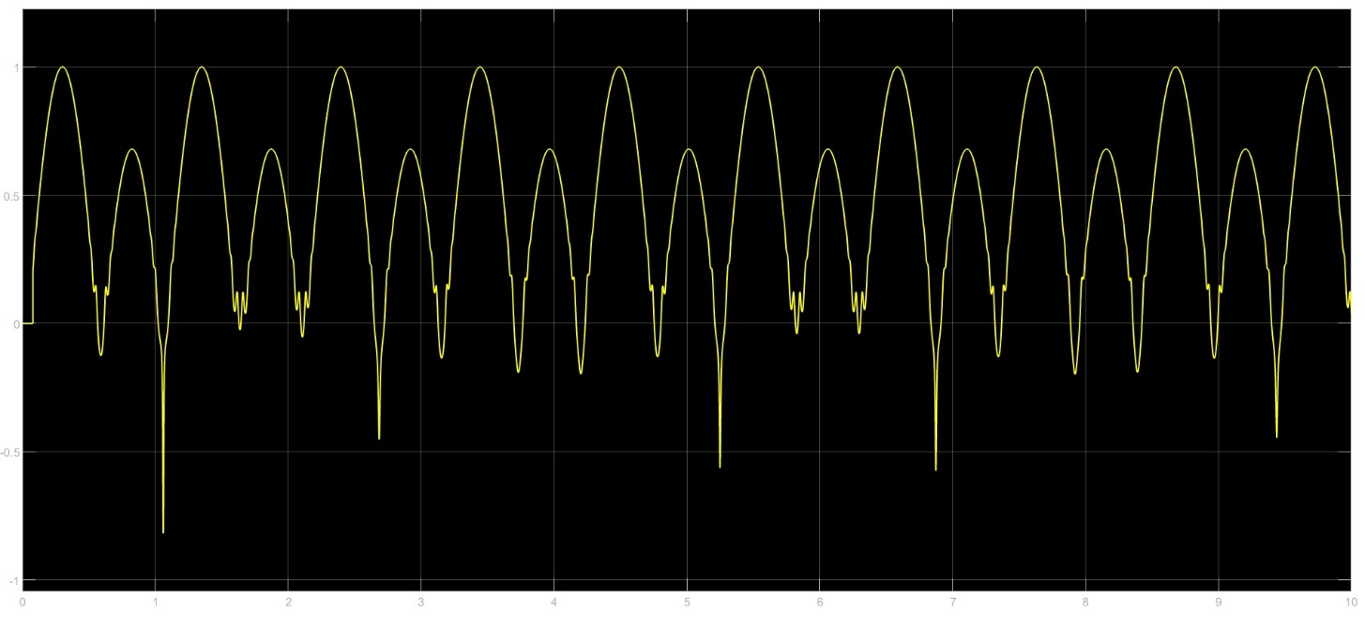

* **Parameter: Deviation ratio (ratio of frequency deviation to modulating frequency).**
* **Effect: Increasing the deviation ratio leads to wider frequency swings in the modulated signal, resulting in a wider bandwidth.**
* **Conclusion: Higher deviation ratios result in a wider frequency spectrum, affecting bandwidth requirements.**

1. **Phase Modulation:-**

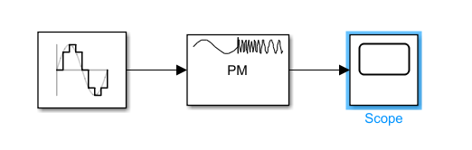**Modulation:-**

**MO**

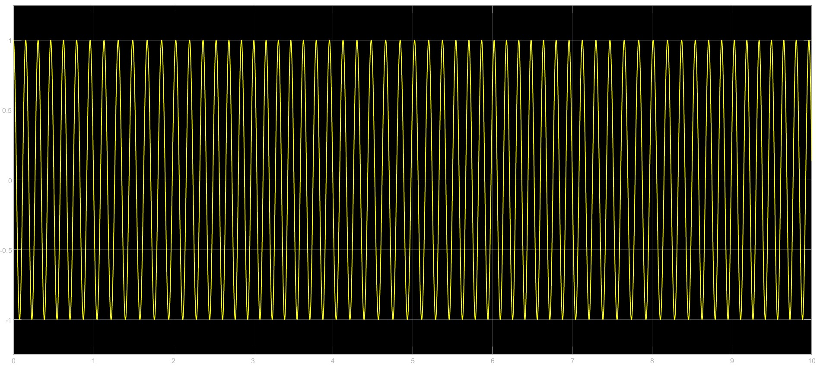

**Demodulation:-**

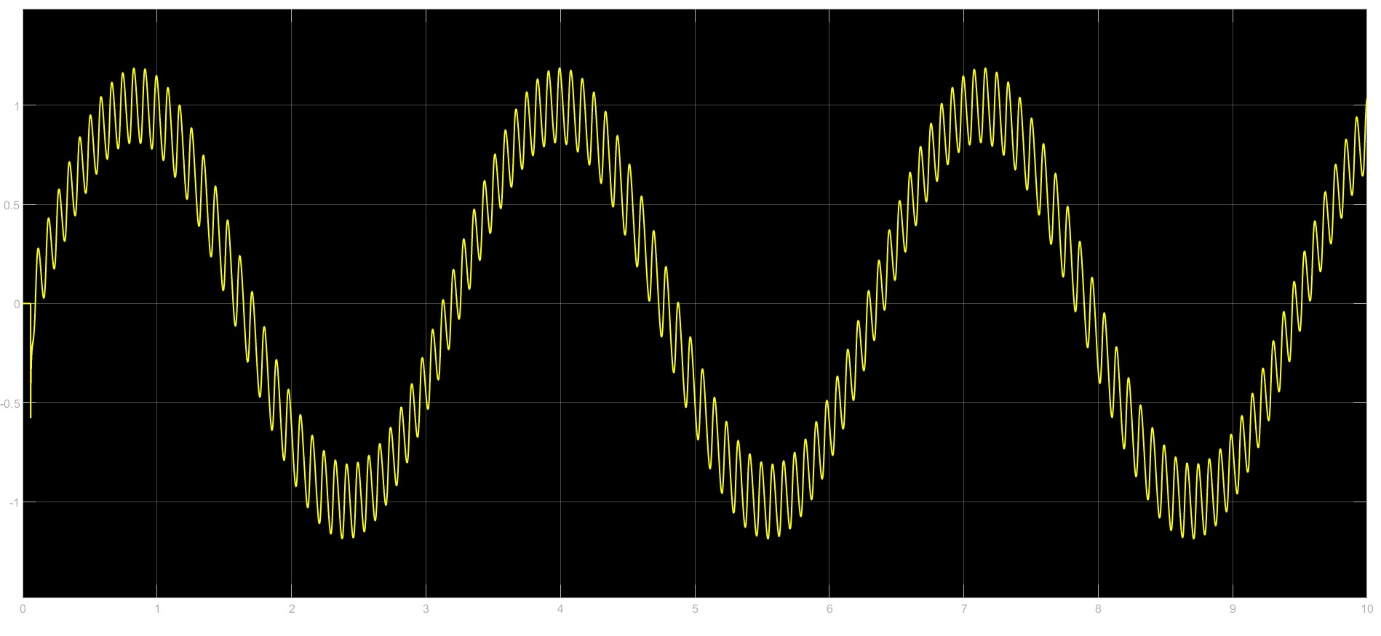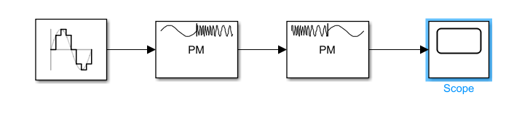

* **Parameter: Phase deviation.**
* **Effect: Increasing phase deviation results in more significant phase changes in the modulated signal, leading to a wider spectrum.**
* **Conclusion: Higher phase deviation increases bandwidth requirements due to a broader frequency spectrum.**

1. **Amplitude Shift Keying:-**

**Modulation:-**

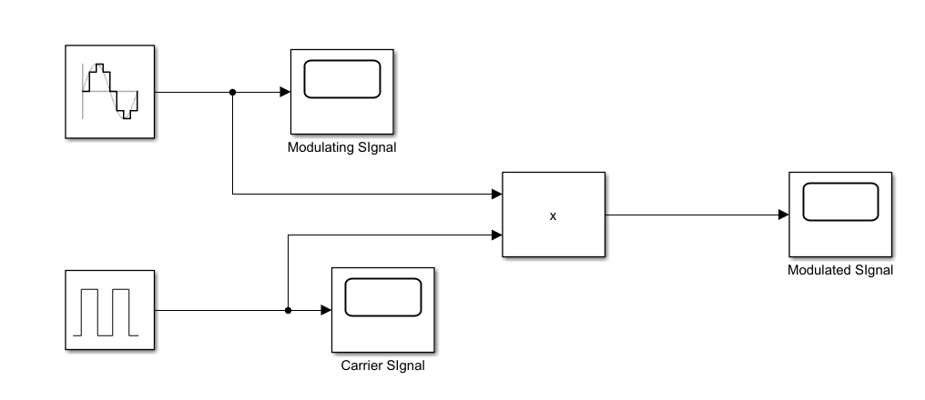

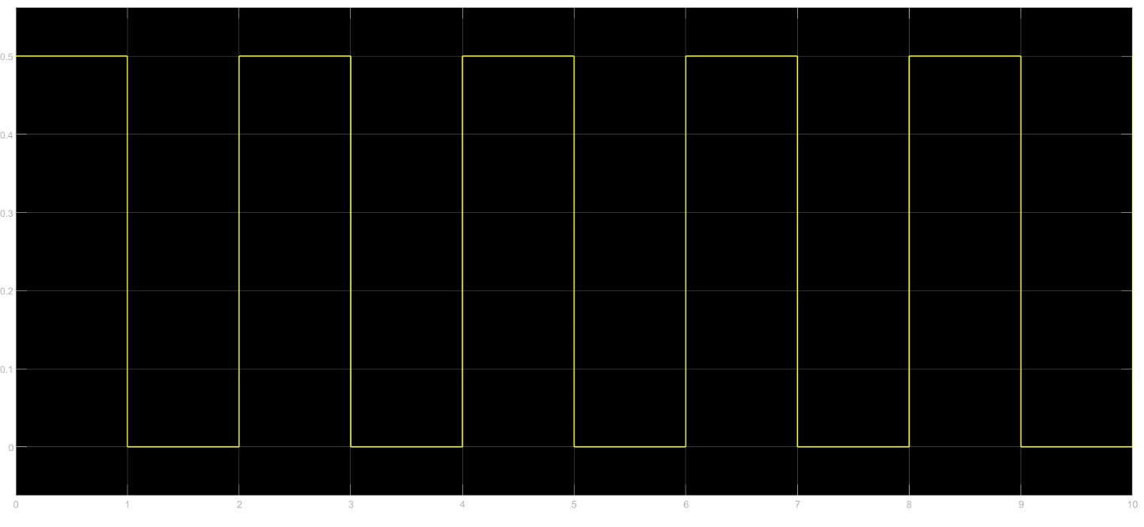**Modulating Signal:-**

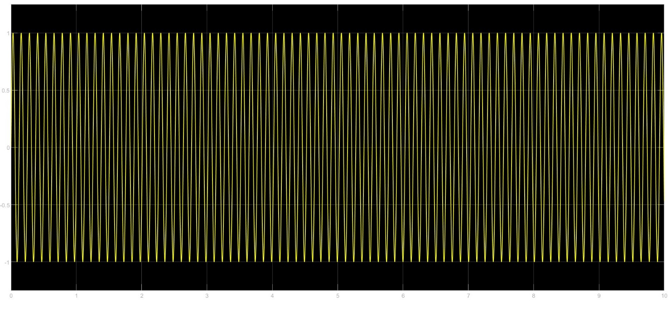**Carrier Signal:-**

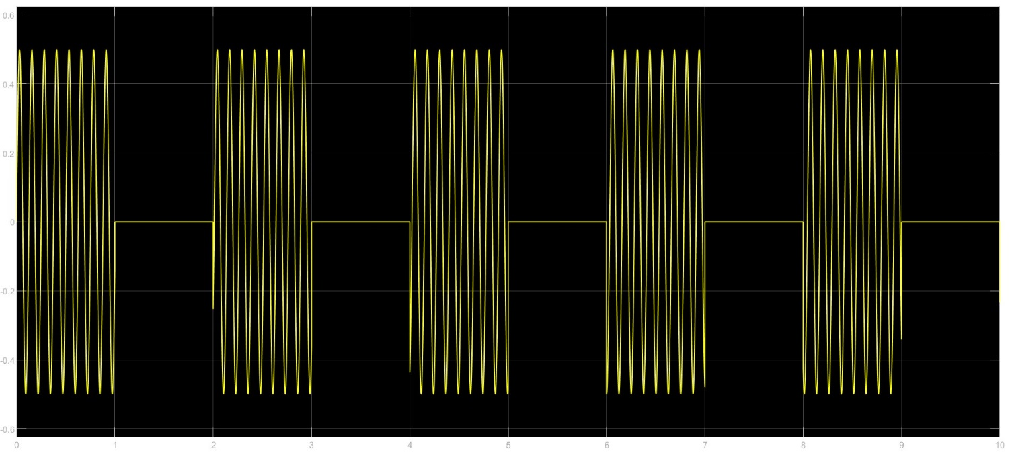**Modulated Signal:-**

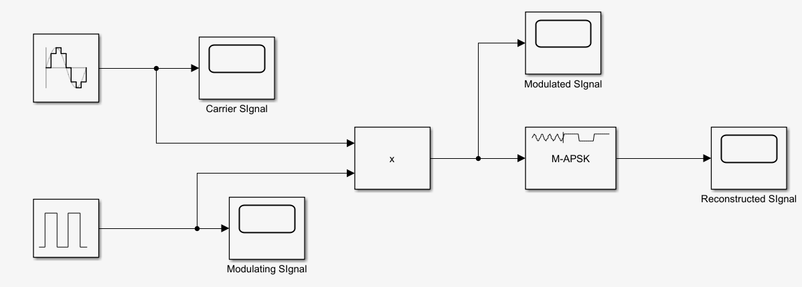**Demodulated Signal:-**

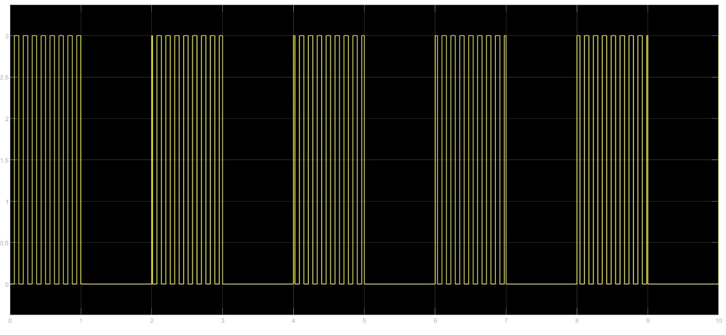**Reconstructed Signal:-**

* **Parameter: Amplitude levels of the carrier signal.**
* **Effect: Increasing the number of amplitude levels increases the number of bits that can be encoded per symbol.**
* **Conclusion: Higher amplitude levels allow for encoding more information per symbol but increase susceptibility to noise.**

1. **Frequency Shift Keying:-**

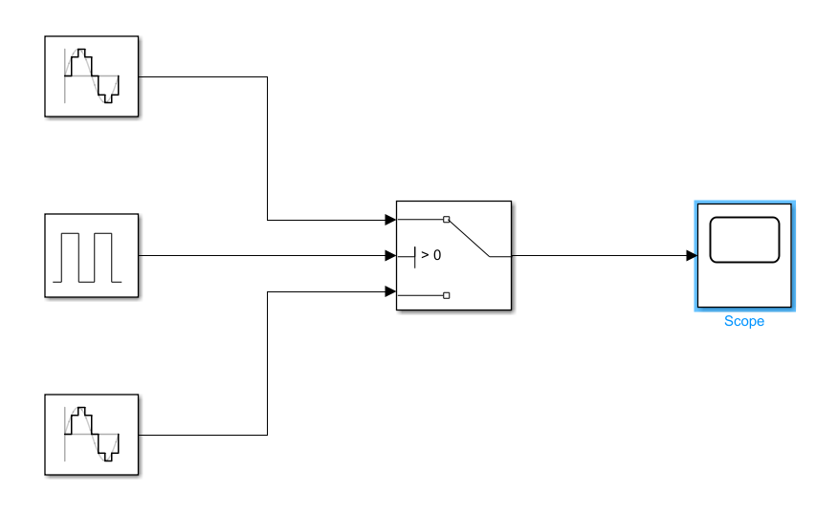**Modulator:-**

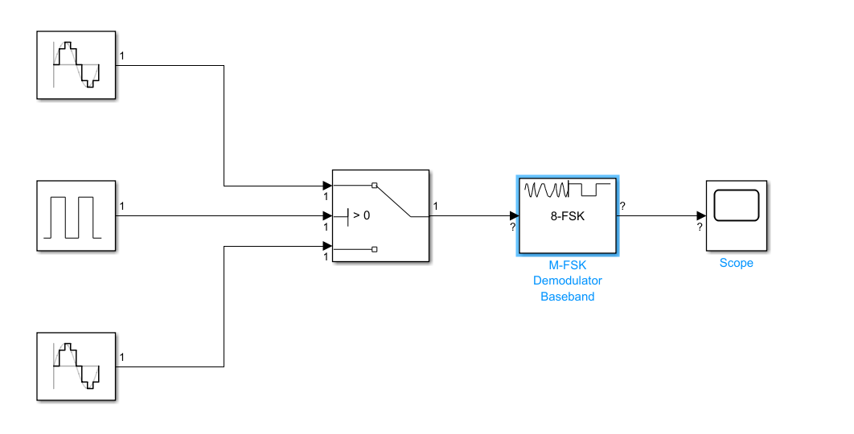**Demodulator:-**

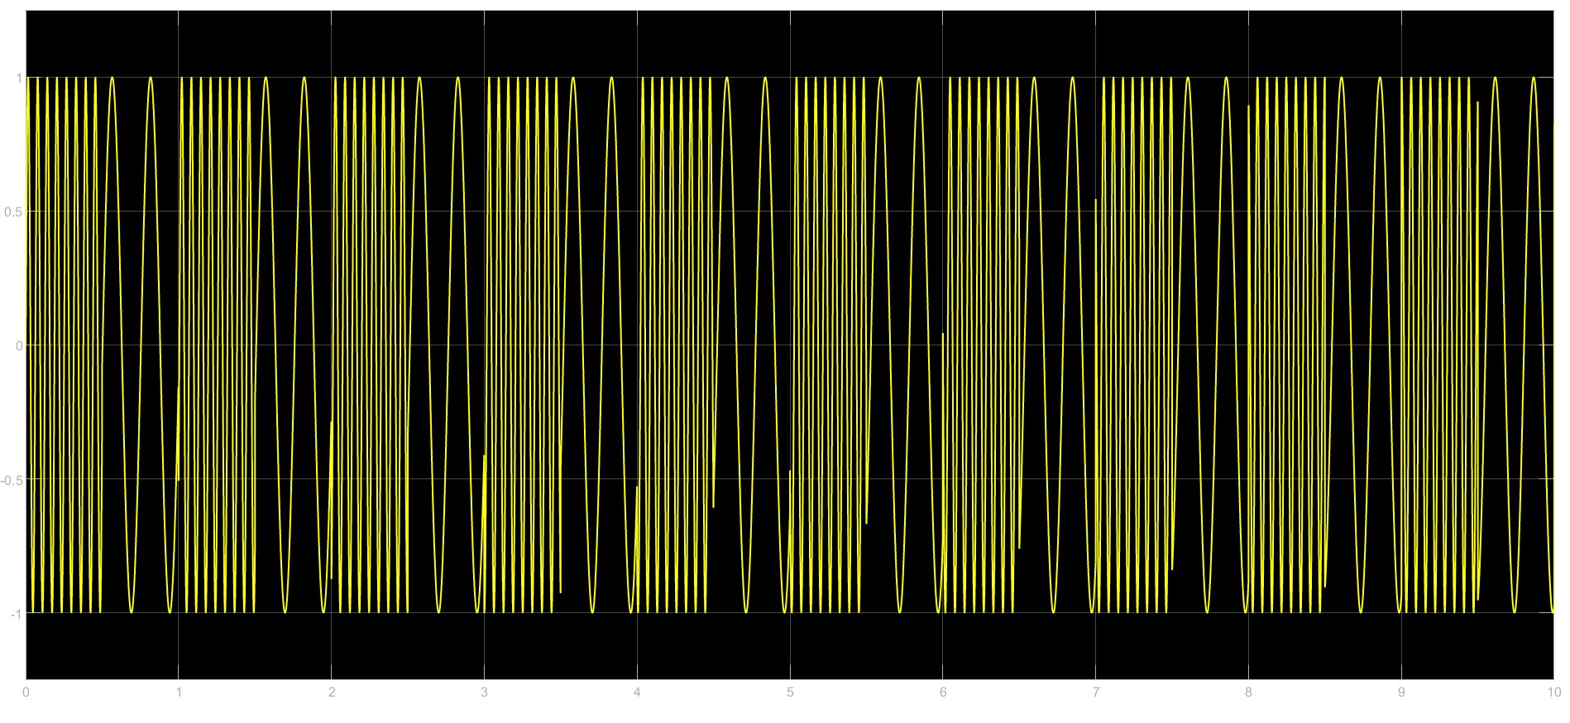**Modulator:-**

* **Parameter: Frequency separation between different symbols.**
* **Effect: Increasing the frequency separation allows for better discrimination between symbols but also increases the required bandwidth.**
* **Conclusion: Larger frequency separations enhance noise immunity but increase bandwidth requirements.**

1. **Phase Shift Keying:-**

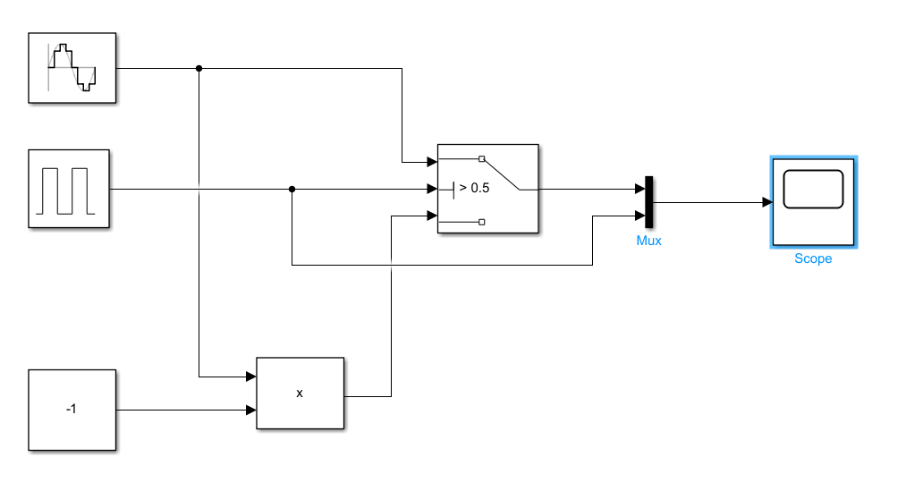**Modulator:**

**Modulated Signal:-**

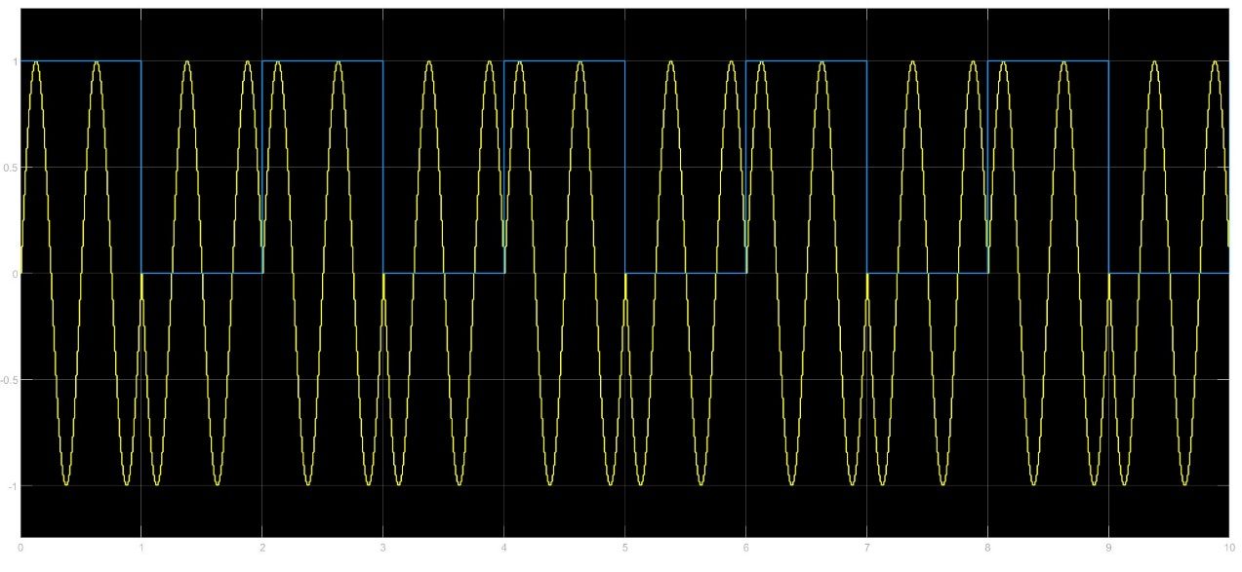

* **Parameter: Phase difference between symbols.**
* **Effect: Increasing the phase difference allows for encoding more bits per symbol but may increase susceptibility to phase errors.**
* **Conclusion: Larger phase differences enable higher data rates per symbol but may require more sophisticated demodulation techniques.**

1. **Binary Phase Shift Keying:-**

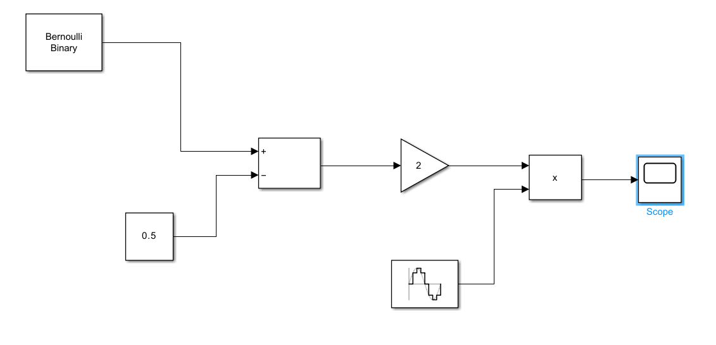**Modulator:-**

**Modulated Signal :-**

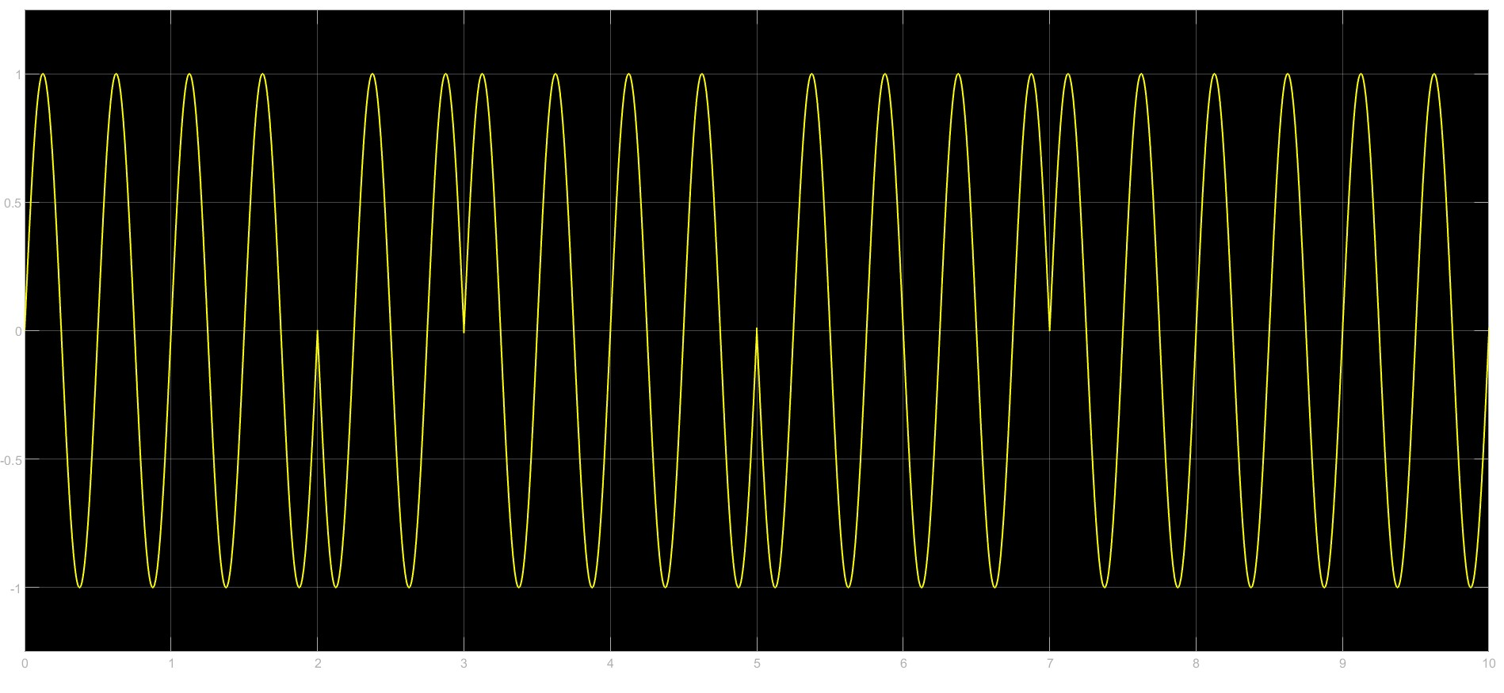

* **Parameter:** Phase difference between the two symbols.
* **Effect:** Changing the phase difference alters the spectral characteristics and affects noise performance.
* **Conclusion:** Adjusting the phase difference allows for optimization between data rate and noise performance.

1. **Quadrature Amplitude Modulation:-**

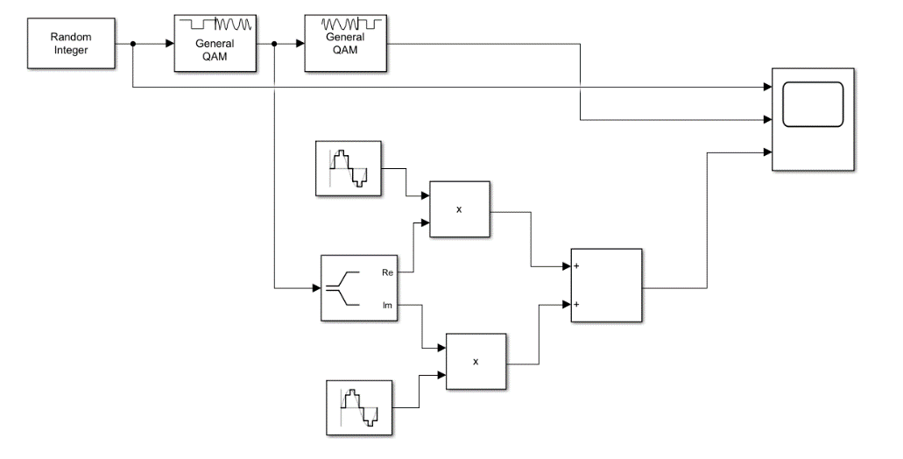**Modulator:-**

**Modulated Signal :-**

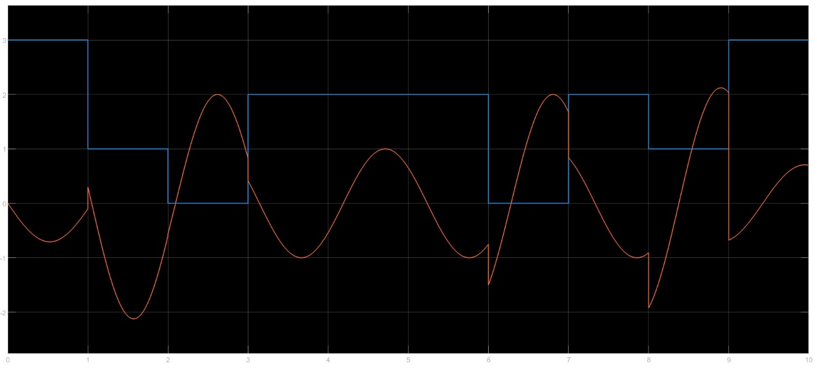

* **Parameter:** Amplitude and phase levels.
* **Effect:** Increasing the number of amplitude and phase levels allows for higher data rates but increases the complexity of modulation and demodulation.
* **Conclusion:** Higher levels enable higher data rates but require more sophisticated signal processing techniques.

1. **Sampling:-**

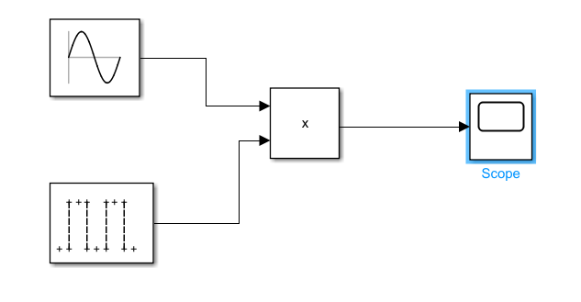**Sampler Circuit:-**

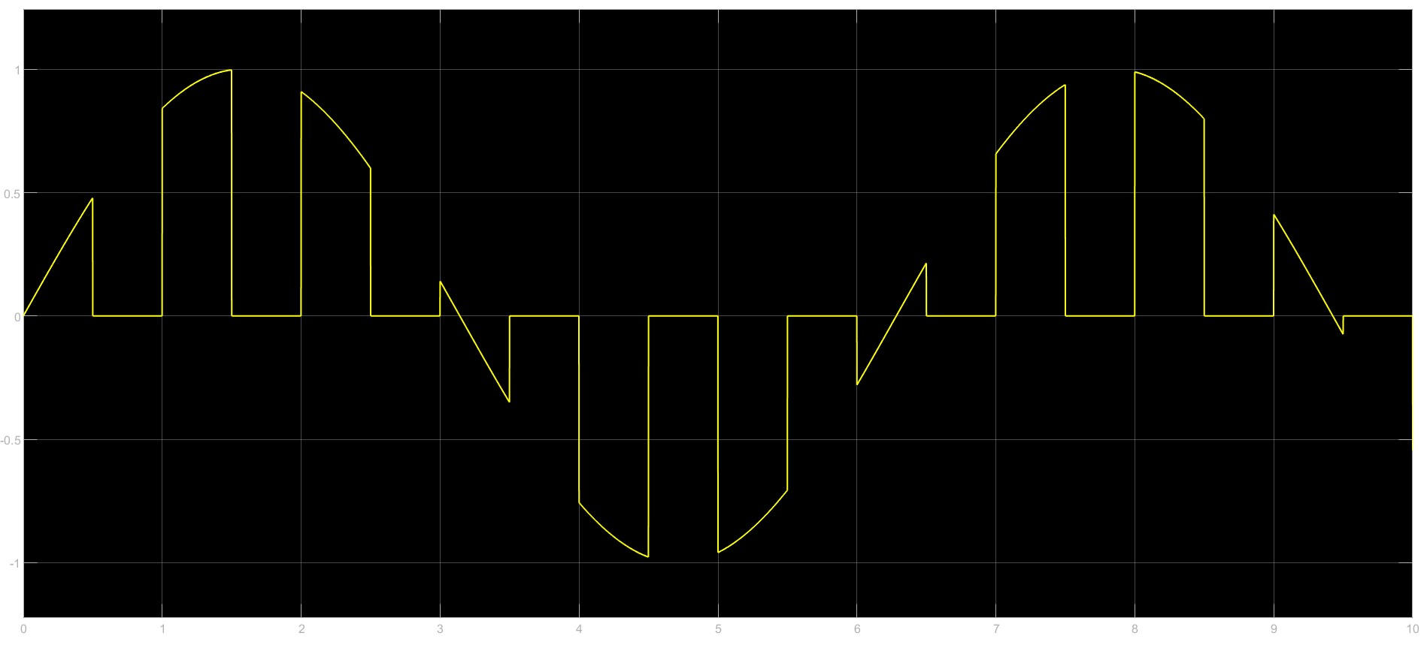**Sampled Output:-**

* **Parameter:** Sampling frequency.
* **Effect:** Increasing the sampling frequency captures more information but also increases the data rate and processing requirements.
* **Conclusion:** Higher sampling frequencies improve signal fidelity but require more resources.

1. **Quantization:-**

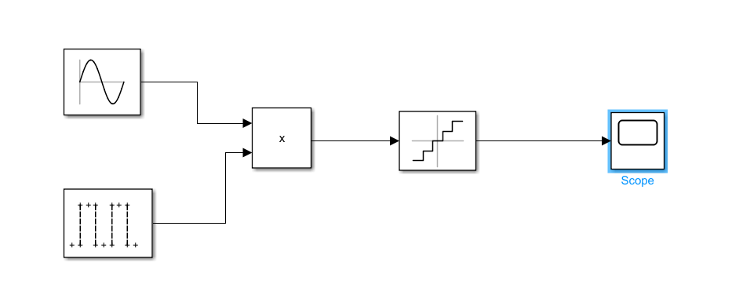**Quantizer:-**

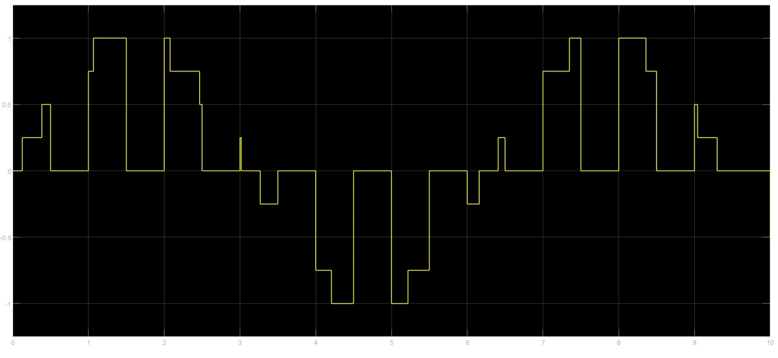**Quantized Output :-**

* **Parameter:** Number of quantization levels.
* **Effect:** Increasing the number of quantization levels improves signal resolution but also increases the required data rate and processing complexity.
* **Conclusion:** Higher quantization levels result in better fidelity but require more resources for processing and transmission.

1. **Analog Communication System:-**

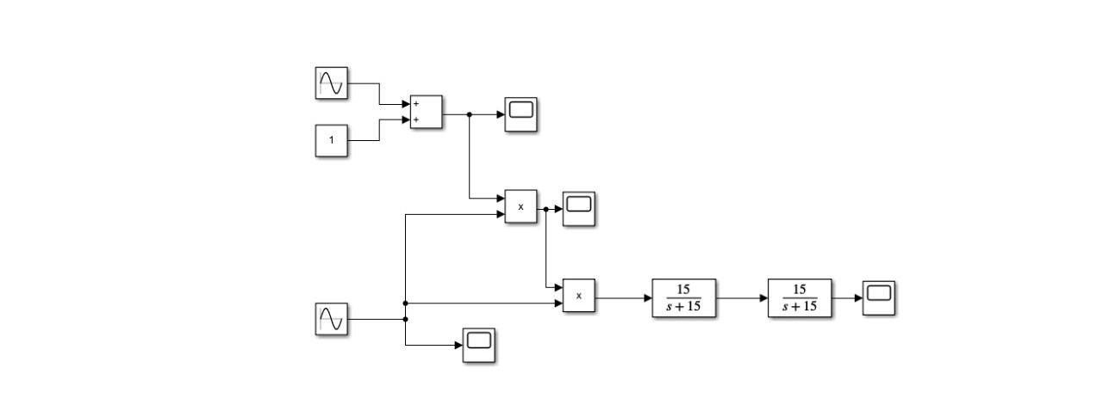**Pulse Amplitude Modulation:-**

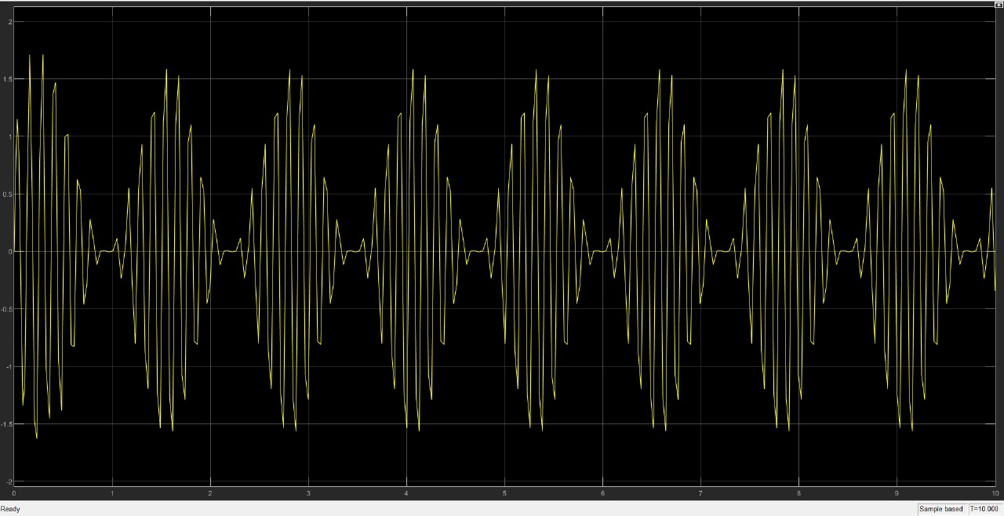**Modulator:-**

**Modulated Signal:-**

* **Parameter:** Amplitude levels of the pulses.
* **Effect:** Increasing the number of amplitude levels increases the resolution of the signal but also increases the bandwidth required for transmission due to higher complexity.
* **Conclusion:** Higher resolution provides better fidelity but at the cost of increased bandwidth requirements.

1. **Digital Communication System:-**

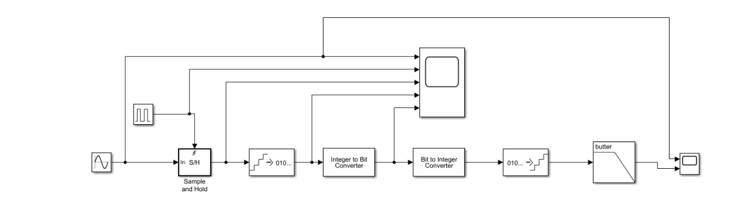**Pulse Coded Modulation :-**

**Output :-**

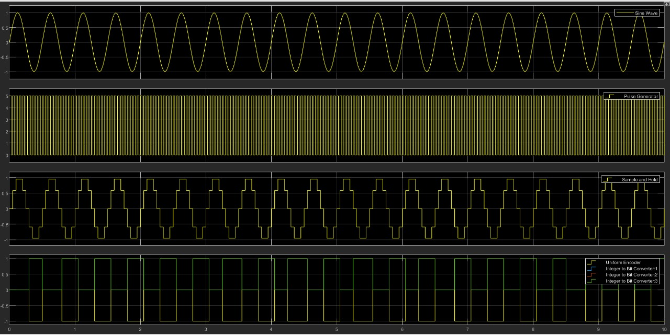

* **Parameter:** Quantization levels.
* **Effect:** Increasing the number of quantization levels improves the fidelity of the signal but also increases the bit rate required for transmission.
* **Conclusion**: Higher quantization levels result in better signal quality but at the expense of increased data rate.